**SOURCE 1**

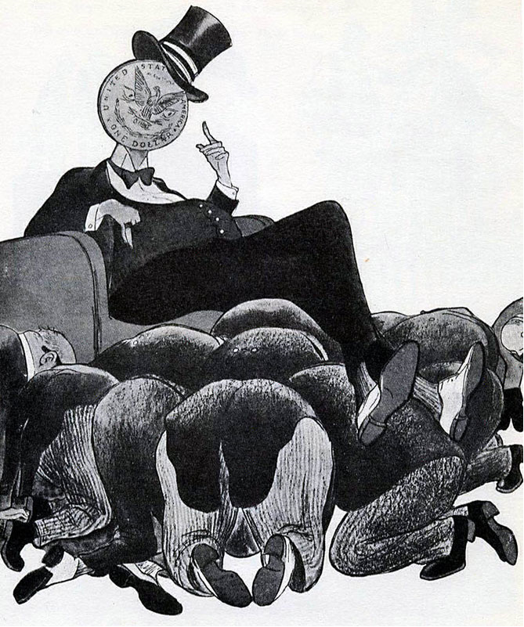

**This cartoon of 1947, from a Soviet magazine, had the caption ‘Capitalist Europe on the Upswing’**

**SOURCE 2**

The Marshall Plan generated a resurgence of European industrialization and brought extensive investment into the region. It was also a stimulant to the U.S. economy by establishing markets for American goods. Although the participation of the Soviet Union and East European nations was an initial possibility, Soviet concern over potential U.S. economic domination of its Eastern European satellites and Stalin’s unwillingness to open up his secret society to westerners doomed the idea.

**Marshall Plan. (n.d.). Retrieved from the Office of the Historian, Bureau of Public Affairs, The United Sates Department of State://history.state.gov/milestones/1945-1952/marshall-plan, Source 3**



**SOURCE 3**

**The McCord Museum is home to an important cartoon collection. More than 10,000 of the works in it were created by John Collins, one of 20th-century Canada's foremost cartoonists. Collins's cartoons were published in the Montreal newspaper, The Gazette, for 40 years.**

**SOURCE 4**

**Communisim in Eastern Europe 1945-1948**

| **Country** | **Date** | **Method** |
| --- | --- | --- |
| Albania | 1945 | The Communists immediately took power. |
| Bulgaria | 1945 | In the 1945 elections, a Communist-led coalition was elected, but the Communists executed the non-Communists. |
| East Germany | 1945 | East Germany was the Soviet zone of Germany. In 1949, they set up a Communist-controlled state called the German Democratic Republic. |
| Romania | 1947 | In the 1945 elections, a Communist-led coalition was elected to power. The Communists gradually took over and in 1947 they abolished the monarchy. |
| Poland | 1947 | Stalin had promised to set up a joint Communist/non-Communist government at Yalta, but then he invited 16 non-Communist leaders to Moscow and arrested them. Thousands of non-Communists were arrested, and the Communists won the 1947 election. |
| Hungary | 1947 | The non-communists won the 1945 elections with Zoltan Tildy as president. However, the Communists' leader, Rakosi, took control of the secret police (the AVO), and executed and arrested his opponents. Tildy was forced to resign and Cardinal Mindzenty, head of the Catholic Church, was imprisoned. By 1948, Rakosi had complete control of Hungary. |
| Czechoslovakia | 1948 | A coalition government was set up and led by the non-Communist Benes. However, the Communists' leader Gottwald made sure they controlled the radio, the army and the police. Gottwald became prime minister and set up a secret police force. Non-Communists were arrested. In 1948, Communist workers went on strike, the non-Communist minister Masaryk committed suicide and Gottwald took over the government. |

**GCSE BBC educational website:** [**http://www.bbc.co.uk/schools/gcsebitesize/history/mwh/ir2/sovietexpansionineasterneuroperev2.shtml 2014**](http://www.bbc.co.uk/schools/gcsebitesize/history/mwh/ir2/sovietexpansionineasterneuroperev2.shtml%202014)

*Name: _________________________ Narrogin Senior High School*



**Unit 4, Modern History**

***SOURCE ANALYSIS ONE***

**The Changing European World Since 1945**

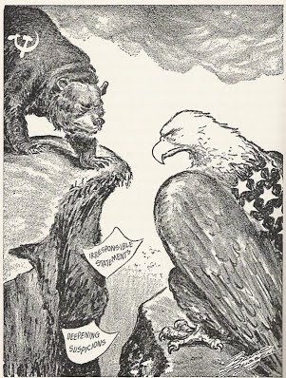

**Marks out of 25:**

**Weighting: 5 %**

**SECTION ONE: SOURCE ANALYSIS SET 1, Unit 4**

This section has ONE question made up of **FIVE (5)** parts. Attempt **ALL** parts. Write your answers in the spaces provided.

* The marks allocation for this section is 25 marks.
* Allow approximately 45 minutes for this section.

Indicate below the document set from the **Document Booklet** you will use to respond to this

question.

Set 1: □ The changing European world since 1945

Set 2: □ Australia’s engagement with Asia

Set 3: □ The struggle for peace in the Middle East

**Question 1**

1. Explain the historical context of **Source 1**. Include the relevant events, people and ideas depicted or represented in the source. *(3 marks)*

|  |  |
| --- | --- |
| **Description** | **Marks** |
| Identifies the focus of the source | 1 |
| Outlines the causes or event that led to the focus of the source | 1 |
| Provides details of the focus of the source, events/people/ideas/dates/places | 1 |
| **Total** | **3** |
| **Note:** This question is concerned with the historical context in which the source is located. Answers should focus on what is in the source and provide the big ‘picture’ for that source. |  |

**See next page**

**(b)** Compare and contrast the purpose of **Sources 1** and **2.** (6 marks)

|  |  |
| --- | --- |
| **Description** | **Marks** |
| Identifies the purpose of the Source 1 | 1 |
| Identifies the purpose of the Source 2 | 1 |
| Identifies elements of comparison between the two sources | 1-2 |
| Identifies elements of contrast between the two sources | 1-2 |
| **Total** | **6** |
| **Note: This question focuses on the reasons for the construction of the sources, and what they aim to achieve. Answers should identify the issue/event/subject of each source; identify the message of the sources; identify the likely purpose for which the source was constructed (or, in the case of the photograph, how the source might have been used, which might produce variations in student interpretation. The response should use evidence from the source to support the response. Lastly, the response should** **explain how they compare (are similar) and contrast (are different) in terms of their purpose.** |  |

**(c)** Identify and explain the message/s of **Source 3**. (3 marks)

|  |  |
| --- | --- |
| **Description** | **Marks** |
| Explain the message of the source | 3 |
| Outlines the message of the source | 2 |
| Identifies an aspect of the message of the source | 1 |
| **Total** | **3** |
| **Note: Look for the message conveyed by the source. Answers should: consider all of the elements of the source: title/ author/ date/ location; identify the issue/ event/ subject; identify the representation or opinion being expressed; provide evidence from the source to support the response.** |  |

**See next page**

**d)** Identify how and discuss why **Source 3** and **4** are contestable. (6 marks)

|  |  |
| --- | --- |
| **Description** | **Marks** |
| Identifies the element/s of contestability for Sources 3 and 4 | 1–2 |
| Discusses the reasons for the contestability of Source 3 | 1–2 |
| Discusses the reasons for the contestability of Source 4 | 1–2 |
| **Total** | **6** |
| Note: The concept of contestability requires a discussion of conflicting historical interpretations represented in source material, specifically why they are different and open to debate. Answers should demonstrate an understanding of what can make a source contestable, whether it provides a certain interpretation of events for which other interpretations exist; or whether the source/s can be disputed as historical evidence. Identify in each source the argument/s, biases, motives or perspectives that can be disputed. Stronger candidates may discuss the nature of the contestability, perhaps by referring to alternative arguments or viewpoints on the interpretations presented by the sources, or by making comparisons between the two sources. |  |

**See next page**

**(e)** Using your knowledge of the whole period of study, evaluate the importance of the

idea of foreign policy represented in the four sources. (7 marks)

|  |  |
| --- | --- |
| **Description** | **Marks** |
| Identification of the themes/ ideas/ events | 1 |
| Placement of the themes/ ideas/ events with the themes/ ideas/ events of the broader historical context of the time. Students should be able to demonstrate a breadth and depth of the time period. | 1–2 |
| Evaluation of the themes/ ideas/ events in relation to those of the broader context. | 1–2 |
| Compare and/or contrast with what is in the sources with the other themes/ ideas/ events within the time period. | 1–2 |
| **Total** | **7** |
| Note: This question does not require reiteration of the messages in the sources.  Evaluate the importance of the theme/idea/event in relation to how they are represented in the sources; relates to the other themes/ideas/events of the whole period.  Answers should identify the themes/ideas/events in the sources; evaluate the importance of what is shown in the sources by using evidence from the sources and the whole historical period; refer to the long-term and/or short-term effects of the theme/idea/event; refer to elements of continuity and/or change evident in the theme/idea/event; demonstrate a depth and breadth of knowledge for the whole time period. |  |

**END OF SECTION**

Question number:

Question number: